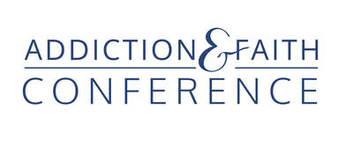

2022 Exhibitor Opportunities
Thursday, 1:30 - 3 P.M. setup
Thursday, 3 P.M.- 6 P.M. & Friday, 8 A.M.- 6 P.M.

In-person Exhibitors - $500; Early Bird special - $450
- One exhibit table with two chairs.
- One full conference registration (Thurs. – Sat.) and up to 9 CEUs.
- Your logo on our website, event app and conference program.

A la carte for In-person Exhibitors
- Full conference registration (Thurs. – Sat.) for second person - $200
includes all events, meals and up to 9 CEUs.
- Registration bag insert $200 (you provide material).

Virtual Exhibits - $125 pay through Eventbrite
These will scroll at the conference between sessions and online before and after presentations. They will be recorded with all the speaking sessions so they will be seen on those recordings as well.
- Includes 200-word description
- Your logo
- Your link
- Up to 30 second audio/video clip (optional)

2 Ways to pay for In-Person Exhibitors
Through Eventbrite - with added fee of $43
Direct pay by check. Save the $43 Eventbrite fee
- Fill out an exhibitor registration form
- Mail it with a check payable to Addiction & Faith Conference to
Louise Olson, 10618 Rich Road, Bloomington MN 55431
- Send the following company information with your check or to glolro@comcast.net
Company logo, contact person and title, e mail address, company name, address,
phone number, website

Contact Pastor Ed Treat, conference director,
to become a sponsor or exhibitor and to answer any questions.
pastored@addictionandfaith.com
651 356-1073

