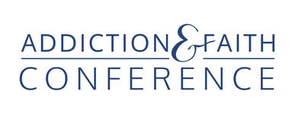

2022 Exhibitor Opportunities
Thursday, 1:30 - 3 P.M. setup
Thursday, 3 P.M.- 6 P.M. & Friday, 8 A.M.- 6 P.M.

In-person Exhibitors - $500; Early Bird special - $450
- One exhibit table with two chairs.
- One full conference registration (Thurs. – Sat.) and up to 9 CEUs.
- Your logo on our website, event app and conference program.

A la carte for In-person Exhibitors
- Full conference registration (Thurs. – Sat.) for second person - $200
includes all events, meals and up to 9 CEUs.
- Registration bag insert $200 (you provide material).

2 Ways to pay for In-Person Exhibitors
Through Eventbrite - with added fee of $43
Direct pay by check. Save the $43 Eventbrite fee
- Fill out an exhibitor registration form
- Mail it with a check payable to Addiction & Faith Conference to
Louise Olson, 10618 Rich Road, Bloomington MN 55431
- Send the following company information with your check or to glolro@comcast.net
Company logo, contact person and title, e mail address, company name, address,
phone number, website

Contact Pastor Ed Treat, conference director,
to become a sponsor or exhibitor and to answer any questions.
pastored@addictionandfaith.com
651 356-1073

