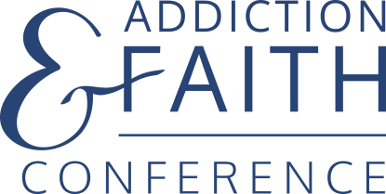
Thursday-Saturday, October 7,8 & 9, 2021
Doubletree by Hilton, Bloomington, MN

How Your Congregation Can Help Fight Addiction

The Center of Addiction & Faith is pleased to present our 3rd annual Addiction and Faith Conference. Building on the strong success of our first two conferences, we again bring together leaders from across the country with varied backgrounds. They will learn important ministries that congregations can employ to address one of the deadliest health crises in America today – now made far worse by the global pandemic!

Here are some ways your congregation can support this important ministry. Please review the information below and consider one or more options as a way of supporting this vital ministry. Join with us as we engage with more than 300 clergy, church leaders & caregivers from across the country.

ALL supporting faith communities will be acknowledged on the conference website and in the conference program.
Please consider one or more of the following opportunities.

www.addictionandfaithconference.com

Basic Support:
- Run the following announcement in bulletins and newsletters over the coming months:

Addiction is a growing health crisis and currently the number one cause of death among those 50 and under. These deaths are preventable! Authorities are crying for help and there is so much more congregations can do to mitigate this problem. Come and learn how your faith community can help save lives. The Addiction and Faith Conference is this February 11, 12 &13, 2021 in Bloomington, Minnesota. It is designed to give congregations the tools they need to fight addiction in all its forms. Please plan to attend, or better yet, bring a team from your church.
www.addictionandfaithconference.com

- Make conference flyers available in your Narthex. Download flyers here:
https://www.addictionandfaithconference.com/uploads/1/2/9/9/129988162/afc_flyer_3_2021final_proof.pdf
Special Sunday:
- Invite Pastor Ed Treat or one of our recovering pastors to preach for an Addiction Awareness Sunday (no fee).

Participate:
- Sponsor a member or a team of leaders to attend this conference. This is a great way to start or strengthen addiction ministry in your congregation.

Sponsor Support:
- Help someone attend – Last year we helped several Seminary and CPE students to attend. Your congregation could offer a scholarship so that a student or underpaid pastor or unpaid parish nurse can attend. $300 each

Foundation Support:
- Encourage your congregation’s Foundation to financially sponsor this event.

FOR INFORMATION, CONTACT PASTOR ED TREAT, 651 356-1073, PastorEd@addictionandfaith.com

