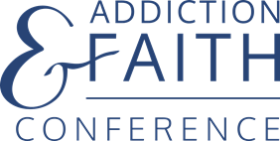

DIRECT REGISTRATION – Hybrid Event

Title _______ First Name ___________________________ Last Name_________________________________

Address___________________________________________________________________________________

City___________________________________________________ State_____________ Zip_______________

Email Address____________________________________________ How Attending? In person Online

Cell phone __________________________________ Work Phone ___________________________________

Religious Affiliation___________________________________________ Clergy? Yes No

Company/Church Name_______________________________________________________________________

How did you hear about this conference? _________________________________________________________

Have you attended previous Addiction & Faith Conferences? No Yes, in 2018 Yes, in 2019
Do you attend other addiction conferences? Yes No
Do you refer people to treatment? Yes No
Will you refer someone to treatment in the next six months? Yes No

For In-Person Attendees only:
Dietary Restrictions?__________________________________________________________________________

Special Needs?_______________________________________________________________________________

RETURN THIS REGISTRATION FORM AND A CHECK FOR $300 PAYABLE TO ADDICTION & FAITH CONFERENCE MAIL TO:
The Addiction & Faith Conference
Louise Olson
10618 Rich Road
Bloomington, MN. 55437-2833

HOTEL ACCOMMODATIONS MADE SEPARATELY FROM OUR WEBSITE: www.addictionandfaithconference.com

