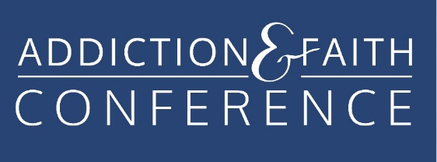

Sponsorship Opportunities

Diamond Level Sponsor $10,000 or more.

- Special welcome and thank you for providing the meal.
- Opportunity to speak for up to 10 minutes at any either of the two banquet dinners.
- Special acknowledgement and signage at the conference.
- One exhibit table with two chairs including full registration for two and CEUs.
- Your logo on our website, event app and featured location in the program.
- Registration bag insert. (you provide inserts)

Platinum Level Sponsor $7500 or more.

- Special welcome and thank you for providing all of the Audio Visual Services including Wi-Fi
- Opportunity to speak for up to 10 minutes at any either of the two banquet dinners.
- Special acknowledgement and signage at the conference.
- One exhibit table with two chairs including full registration for two and CEUs.
- Your logo on our website, event app and featured location in the program.
- Registration bag insert. (you provide inserts)

Gold Level Sponsor up to $5,000

- Special welcome and thank you for providing the meal—breakfast or lunch.
- Opportunity to speak for up to 5 minutes at breakfast or lunch.
- One exhibit table with two chairs including registration for two and CEUs.
- Your logo on our website, event app and conference program.
- Registration bag insert (you provide inserts).

Silver Level Sponsor $2500

- Special thank you for providing for a coffee break..
- One exhibit table with two chairs including registration for two and CEUs.
- Your logo on our website, event app and conference program.
- Registration bag insert (you provide inserts).

Bronze Level Sponsor $500 - $2499

- Your logo on our website, event app and conference program.
- One exhibit table with two chairs including registration for one and CEUs.
- Registration bag insert (you provide inserts).

Scholarship Sponsor $300

- Special thank you for making it possible for others to attend on our website, event app and conference program.

Friends of the Addiction and Faith Conference $100 - $499

- Special mention on our website, event app and conference program.

